**Probability and Statistics - IT2120**

**Lab Sheet 05**

**IT24102701**

**Abayawardena W.A.A.U**

01). Import the dataset (’Exercise– Lab 05.txt’) into R and store it in a data frame called ”Delivery Times”.







02). Draw a histogram for deliver times using nine class intervals where the lower limit

is 20 and upper limit is 70. Use right open intervals.

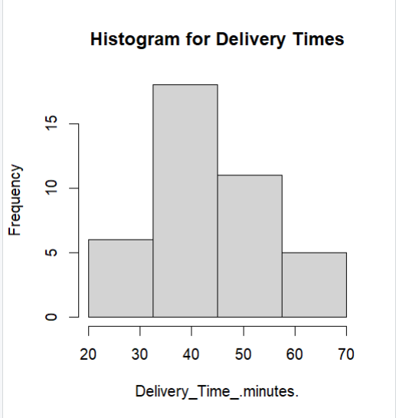

04). Draw a cumulative frequency polygon (ogive) for the data in a separate plot.



